EXPERIMENT NO :09

Name : Pravin Patil   
Roll NO : 3138

Sub :Network Security

Class : TE(A)

**AIM :** In this experiment, you are asked to design the triple DES cryptosystem provided that you are given an implementation of DES.

**OBJECTIVE :** To understand how to convert a DES implementation to a triple-DES implementation.

**OUTPUT :**

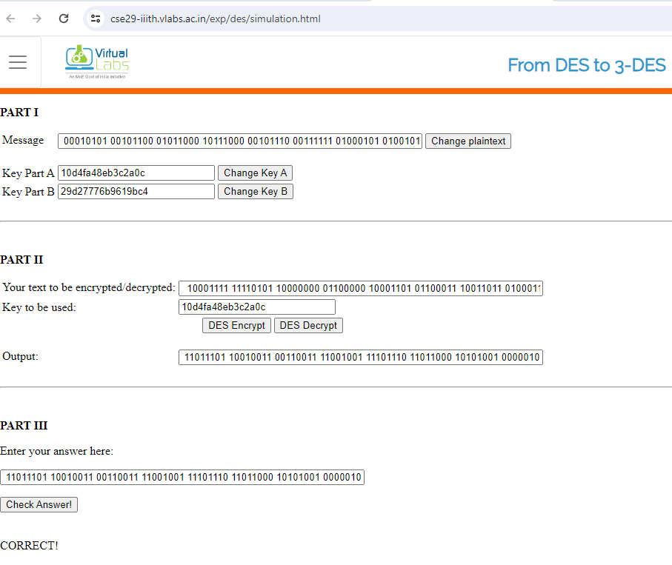

**Experiment No :10**

Name : Pravin Patil   
Roll NO : 3138

Sub :Network Security

Class : TE(A)

**AIM :** In this experiment, you are asked to encrypt long messages using various modes of operation wherein a block cipher (in this case, AES) is provided to you .

**OBJECTIVE:** To understand the need, strenghts and weaknesses of various modes of operation of block ciphers.

**OUTPUT :**

